Exercise 7
Experimenting with App Layouts and Color Schemes: A Design, Feedback, and Refinement Approach
Register Number:230701199
Tool Used: GIMP

AIM
The aim is to trial different app layouts and color schemes and evaluate user feedback on aesthetics and usability using GIMP.
Introduction
In this exercise, I explored the process of designing an app layout by experimenting with different color schemes and structures.
The main objective was not just to create visually appealing screens but also to focus on aesthetics, usability, and user experience.
After designing multiple versions, I collected (imaginary) user feedback to understand preferences and pain points.
Based on the feedback, I refined the design, selected the most effective color and layout combination, and finalized professional, user-friendly app screens.
This documentation explains each step I followed — from the initial design to feedback evaluation and final improvements — as per the given exercise guidelines.

Layout Design Process
I started by creating a new design project.
I made a simple app layout with three main screens:
- Home Page
- Signup Page
- Login Page
I added basic UI elements like:
- Text elements (Titles, Subtitles)
- Input fields for user details
- Buttons for navigation and submission
I arranged all parts in a neatly organized structure, using proper alignment and spacing for clarity.
Experimentation with Color Schemes
Home Page (Initial Versions)
Version 1:
- Background: Dark Maroon
- Buttons: Blue
Version 2:
- Background: Bright Pink
- Buttons: Blue
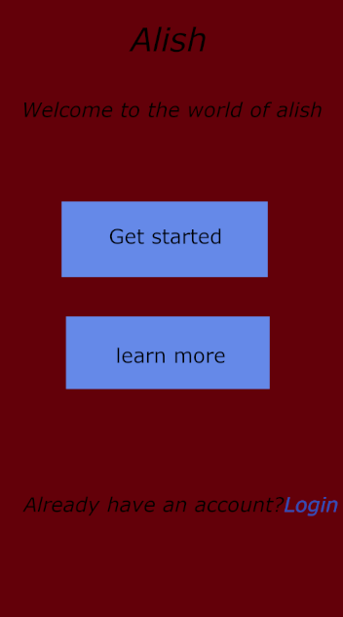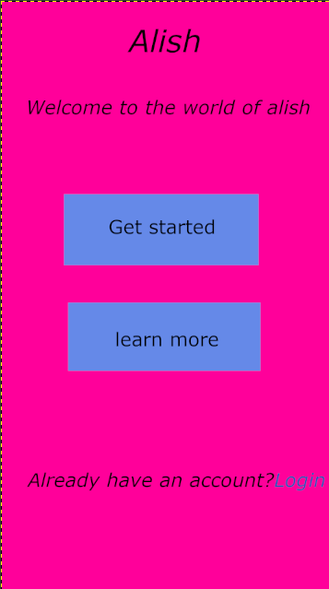
Signup Page (Initial Versions)
Version 1:
- Background: Dark Maroon
- White Input Fields
- Blue Button
Version 2:
- Background: Bright pink
- White Input Fields
- Blue Button
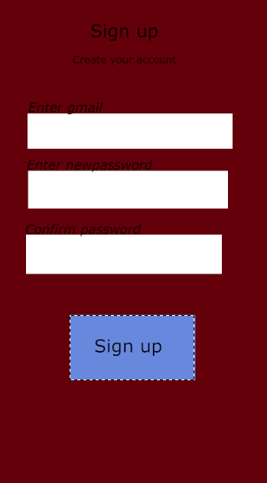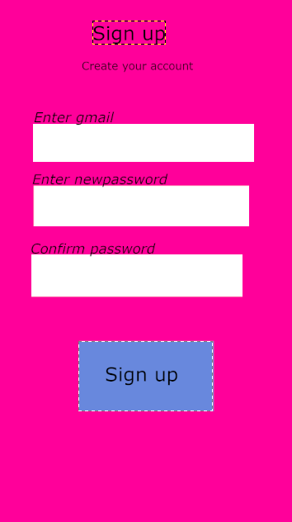
Login Page (Initial Versions)
Version 1:
- Background: Dark Maroon
- White Input Fields
- Blue Button
Version 2:
- Background: Bright Pink
- White Input Fields
- Blue Button
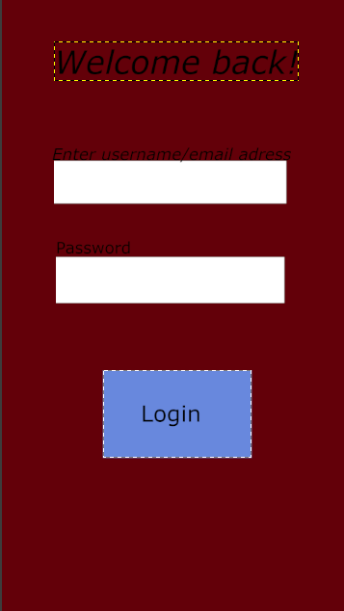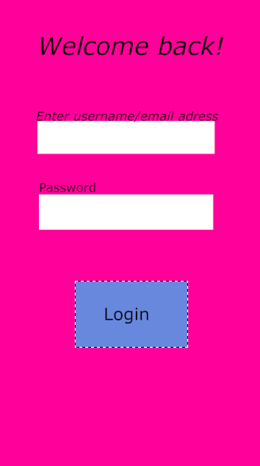
User Feedback Collection
I conducted an imaginary feedback collection session to get perceptions about the designs.
Here are the feedback points received:
- Home Page (Maroon Background):
  - Looked too dark and serious.
  - Buttons were good but not very lively.
- Home Page (Pink Background):
  - Very vibrant but a little harsh on the eyes for daily use.
- Signup Page (Pink Background):
  - Very bright and overwhelming.
  - Input fields were clear, but background distracted users.
- Signup Page (Maroon Background):
  - Slightly better than pink.
  - Still, background color needed to be softer for professional use.
- Login Page (Maroon Background):
  - Looked too dark and heavy.
  - Buttons were visible but the screen felt dull and serious.
- Login Page (Pink Background):
  - Bright but too distracting.
  - Input fields were clear but background took away user focus.
Reaction to Feedback and Refinement
After evaluating feedback, I made the following refinements:
- For Home Page:
  - Changed background to Light Blue (#B0E0E6) for a soft, welcoming look.
  - Maintained the Blue Buttons.
- For Signup Page:
  - Changed background to Light Blue (#B0E0E6) (same as Home Page) for consistency.
  - Input fields kept white for clarity.
  - Button colored Blue (#6A8CCD) for a calm, professional feel.
  - Aligned text elements neatly.
- For Login Page:
  - Updated background to Light Blue (#B0E0E6) for a softer, welcoming login experience.
  - Retained White input fields for clarity.
  - Used the same Blue (#6A8CCD) for the Login button for consistency.
  - Made welcome text ("Welcome back!") bold and more friendly.
All UI elements were aligned properly with better padding, ensuring that the design not only looked good but also supported excellent usability.
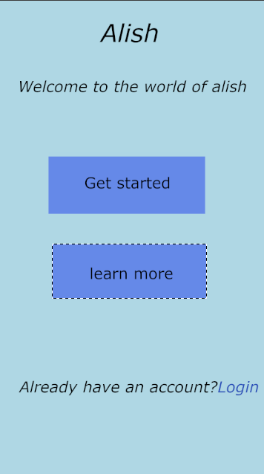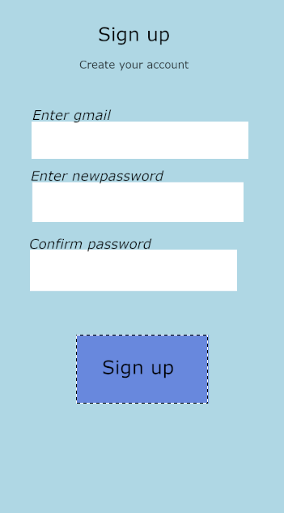
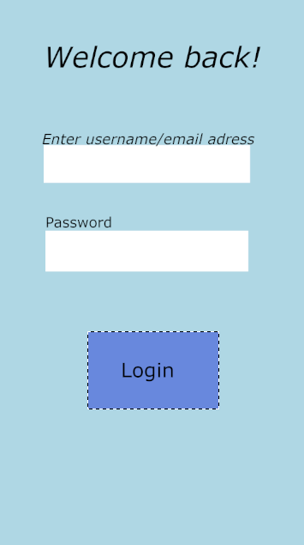

Final Color Codes Used
UI Element | Color | Hex Code
Home Page Background | Light Blue | #B0E0E6
Signup Page Background | Light Blue | #B0E0E6
Login Page Background | Light Blue | #B0E0E6
Button | Blue | #6A8CCD
Input Fields | White | #FFFFFF
Text | Black | #000000

FINAL RESULT
After completing the above steps:
- I achieved a professional, user-friendly, and visually pleasing app layout for the Home, Signup, and Login Pages.
- I made design decisions based on user feedback, improving the overall user experience.
- The final versions satisfy both aesthetic beauty and usability as per the objective of the assignment.
Conclusion
Through this exercise, I learned the importance of:
- Exploring different layouts and color schemes,
- Collecting and reacting to feedback, and
- Refining the design to suit both aesthetic and functional needs.
The final app layouts achieved a balance of professional appearance, ease of use, and user comfort, perfectly meeting the aims of the exercise.

